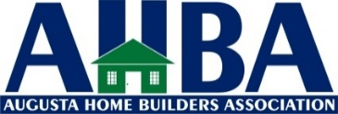
Application for Membership
Company Name_________________________________________________ Date:__________________
Business Address________________________________________________________________________
City _______________________ State______ Zip Code___________e-mail________________
Contact Person_________________________________Title_______________Phone:_________________
Phone Number__________________Fax_______________e-mail____________________________
Membership Classification: See back for codes
(Please check one) Please complete this section for Builder and Associate members only.
( )Builder ( )Builder Class A ( )Associate ( )Associate Class A ( )Affiliate
$490 (not Class A) $590 (Class A) $490 (not Class A) $590 (Class A) $100
Business Activities $Vol. Units # of Employees Title

If Affiliate, Employer’s Master ID Required Below. Other Classifications (please specify)

Tell us about your company/products/services____________________________________________________

Sponsored by_______________________________________________________________________________
Agreement to AHBA:
I agree to abide by the Constitution and By-Laws of the Augusta Home Builders Association, of the National Association of Home Builders of the United States with which it is affiliated, and of the affiliated Home Builders Association of Virginia. A remittance of $590 or $490 representing my annual membership dues in the affiliated associations accompanies this application. A reminder that dues payments to Augusta Home Builders Association are not deductible as charitable contributions for federal income tax purposes. However, dues payments may be deductible as ordinary and necessary business expense, subject to exclusion for lobbying activity. Because a portion of your dues is used for lobbying by NAHB, HBAV and Augusta Home Builders Association, 9.7% of the State dues, or $57.23 (if paying $590) or $47.53 (if paying $490) and $9.70 (if affiliate)is not deductible for income tax purposes, and 18% of the National dues or $35.64 is not deductible if Builder or Associate (any classification) and $2.70 is not deductible if Affiliate. An Associate or Builder (Class A) paying $590 in 2023 will not be able to deduct $92.87 and Associate or Builder (Not Class A) paying $490 will not be able to deduct $83.17. An affiliate paying $100 will not be able to deduct $11.40 (2023 Tax Year)

Signature of applicant____________________________________________________________________________________
Please make membership check payable to AHBA, Inc. and mail to address below or give it to your member sponsor.
AHBA -- P.O. Box 36, Waynesboro, VA 22980 (Phone 540-942-4644).
Membership Information Reporting Form Codes
Business Activity Codes: Enter the member’s most important business activities from the list of codes below
(enter up to 3 different codes). Note: For “other” associate (code Z), you must fill in
the blank for Other business Classification if that member is to receive Builder Magazine.

Builder Member Associate Member Subcontractors and Specialty
Classification Classification Trade Contractors______
A. Single Family Spec/Tract Building L. Accounting W1 Carpentry Work
B1 Single Family General Contracting M1 Architecture W2 Electrical Work
B2 Single Family Custom Building M2 Engineering W3 Masonry, Stone Work, Tile Setting,
Plastering
C Multifamily Building (Condo/Coop) M3 Planner or Designer W4 Landscaping
D Multifamily Building/Ownership N Legal Services WS Plumbing, Heating, and A/C
(rental units)
E Multifamily General Contracting O Computer Products & Services W6 Roofing, Siding & Sheet Metal Work
F Remodeling – Residential P1 Commercial Banking/Thrift Inst. W7 Painting and Paper Hanging
G Remodeling – Commercial P2 Mortgage Banking W8 Floor Laying & Other Floor Work
H Commercial Building (Own Account) R Marketing, Advertising or PR W9 Concrete Work
I Commercial General Contracting S Building Material Manufacturing WA Excavation Work
J Land Development T Property Management ` WC Land Surveyor
K Manufacturing of Modular/Panelized/ U Real Estate WD Security Systems
Log Homes Y Utilities WZ Other Subcontractor (specify)
Z Other (specify)
Wholesale Dealers/Distributor Retail Dealers/Distributor
X1 Appliances V1 Appliances
X2 Building Materials/Lumber V2 Building Materials/Lumber
X3 Floor Coverings V3 Floor Coverings
X4 Paint/Wall Coverings V4 Paint/Wall Coverings
X5 Other Wholesale Dealership (specify) V5 Other Retail Dealership (specify)

Annual Dollar Volume:
Enter the member’s approximate annual dollar volume of new residential construction/development, using the following codes: 0 – under $500,000 2 - $1 million - $4,999,999 4 - $10 million or over
1 - $500,000 - $999,999 3 - $5 million - $9,999,999 5 – No construction activity

Annual Number of Residential Dwelling Units Built in past 12 months:
Enter the member’s approximated number of units built using the following codes:
- 0 units 3) 11 – 25 units 5) 101 – 500
- 1 – 10 4) 26 – 100 6) Over 500
Total Paid Employees:
Enter the total employees in the blanks provided. Include the member in your total figure.

Business Title: Enter the code that best describes the member’s business title, using the following codes:
1 President 4 Sales and Marketing Manager/Director 7 Owner/Princinal or Partner
2 VP/General Manager 5 Architect/Designer or Engineer 8 Other (specify)
3 Construction Superintendent 6 Financial Manager/Director

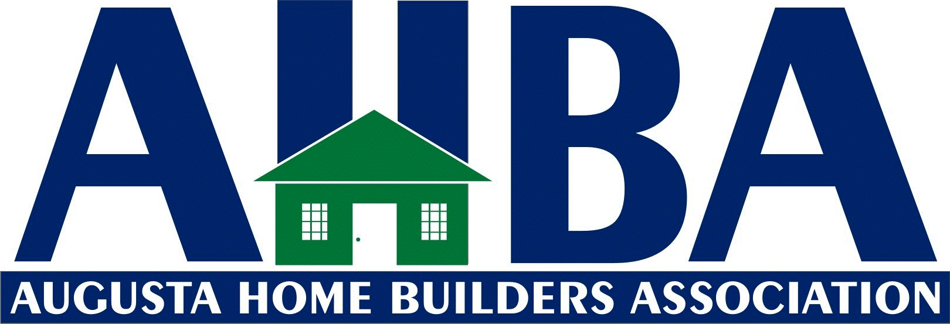

Committee List
Please consider serving on one of the committees below and check the box by the committee you are willing to serve on. Return with application. Thank you for your participation.

Golf Tournament– Chairman - Thomas Shields, Jr.
This committee is responsible for our annual golf tournament which includes organization of tournament, sponsorships, and door prizes.

Public Relations/Programs Committee –
Co-Chair Hannah Shields Wood
Public Relations and Membership Committees work together to coordinate our monthly meeting guest speakers and programs for the year. They are tasked to come up with new and interesting topics for the membership meetings, and work together to increase membership through drives while retaining existing members. They meet the 1st Wednesday of each month at 4 P.M. at Fishin Pig in Waynesboro.

Building and Public Affairs Committee – Chair, Scott Williams
This committee has been established to be AHBA’s advocate with the local governments and boards. This committee will meet or speak with local governments on behalf of our Association or its members when help is needed with a project or to advocate for certain causes. One key project that this committee will advocate for on a continual basis is one that focuses on efforts that can help keep our building and lot costs in line. Meeting times and location to be determined.

